**iRevolution: A Data-driven Exploration of Apple's iPhone Impact in India**

**1. Introduction**

***1.1 Overview***

**The world has changed as a consequence of the increasing use of smartphones, which have improved communication, connected people, and revolutionized many different businesses. With its main product, the iPhone, capturing markets around the world, Apple Inc. has emerged as a prominent player among the top smartphone makers. India, one of the economies with the greatest economic growth, has seen a tremendous increase in smartphone usage, making it an interesting market to study the effects of Apple's iPhone.**

**In order to shed light on important factors like market penetration, customer preferences, economic ramifications, and societal changes, this research report will perform a datadriven investigation of the impact of the iPhone in India. This study will offer invaluable insights into the transformative impact of the iPhone on India's technological landscape and the lives of its consumers by using advanced data analytics techniques and analysing large datasets.**

***1.2 Purpose***

**The technical architecture involves leveraging the data analytics capabilities of Tableau for visualizations and analysis. The architecture comprises several components to ensure efficient data processing and visualization.**

**At the core of the architecture is the data infrastructure, which includes data sources such as market reports, economic indicators, and surveys conducted among iPhone users in India. These data sources are collected and stored in a structured format for further analysis. Tableau is used as the primary data visualization tool. It connects to the data sources and allows for data extraction, transformation, and loading (ETL) processes.**

**Today, Apple’s iphone enables users to create interactive and visually appealing visualizations, charts, and dashboards based on the analysed data.**

**2. Problem Definitions and Design Thinking**

**A. Empathy Map**

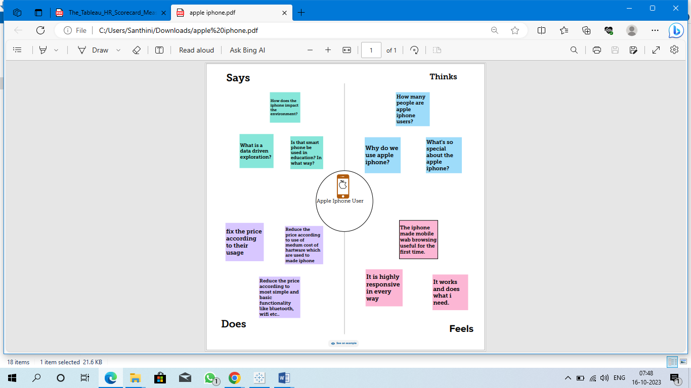

**B. Ideation and Brainstroming Map**

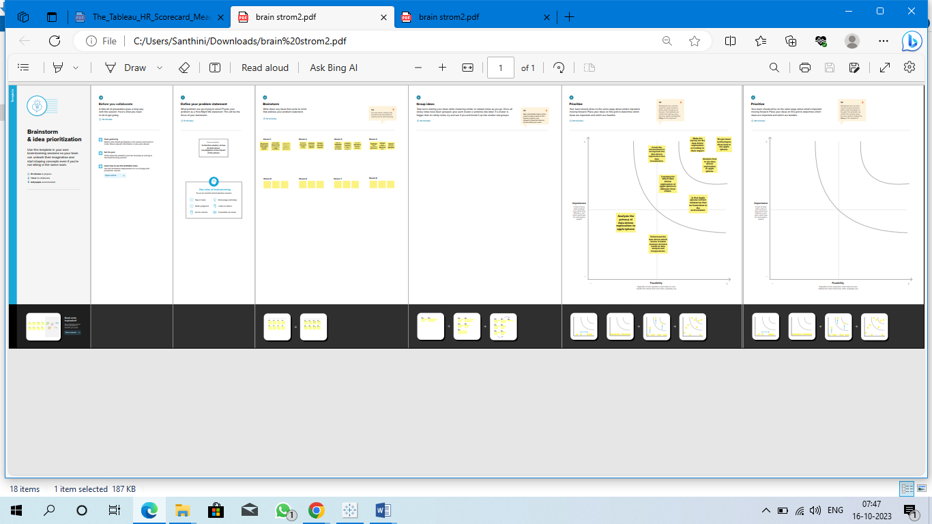

**3. Result**

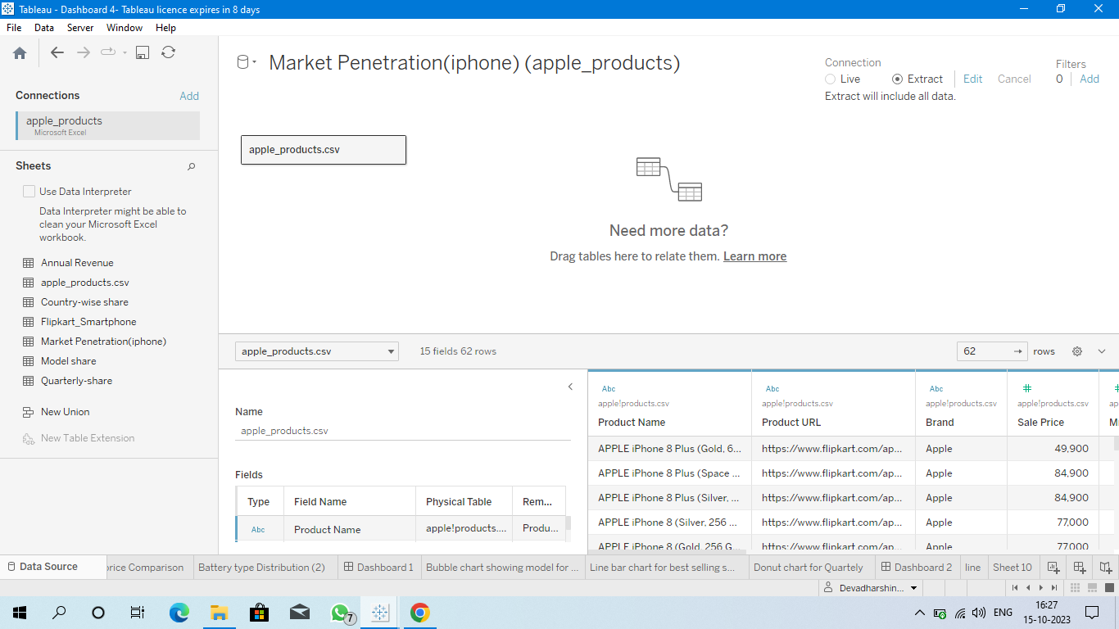

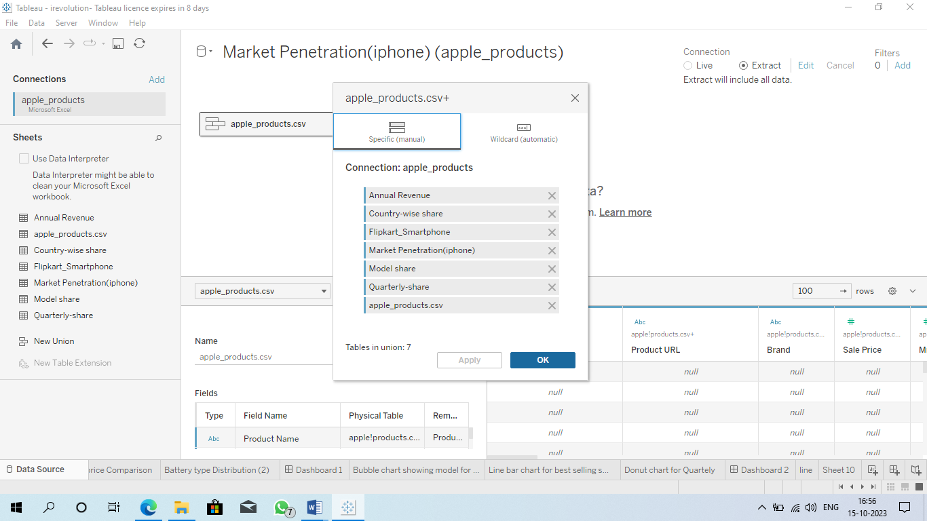

**KPI**

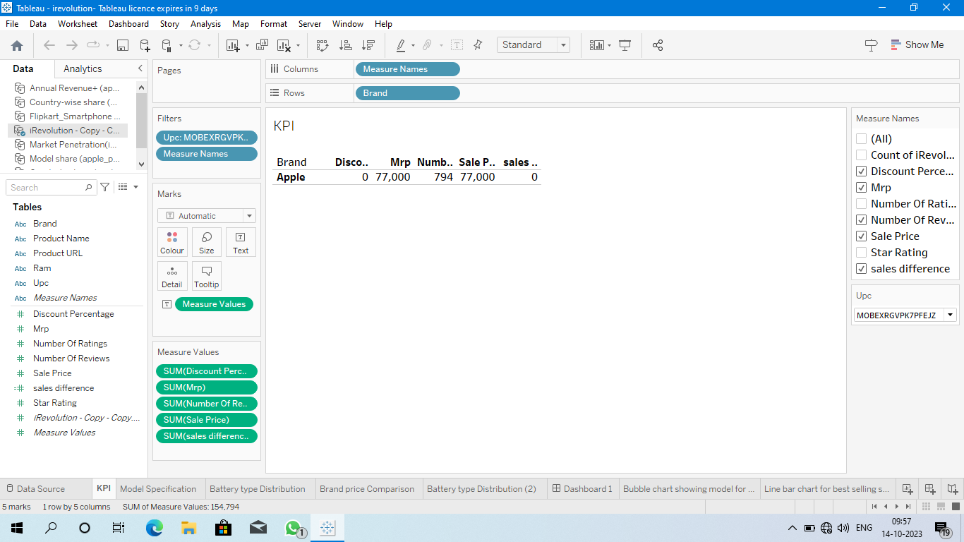

**Model specification**

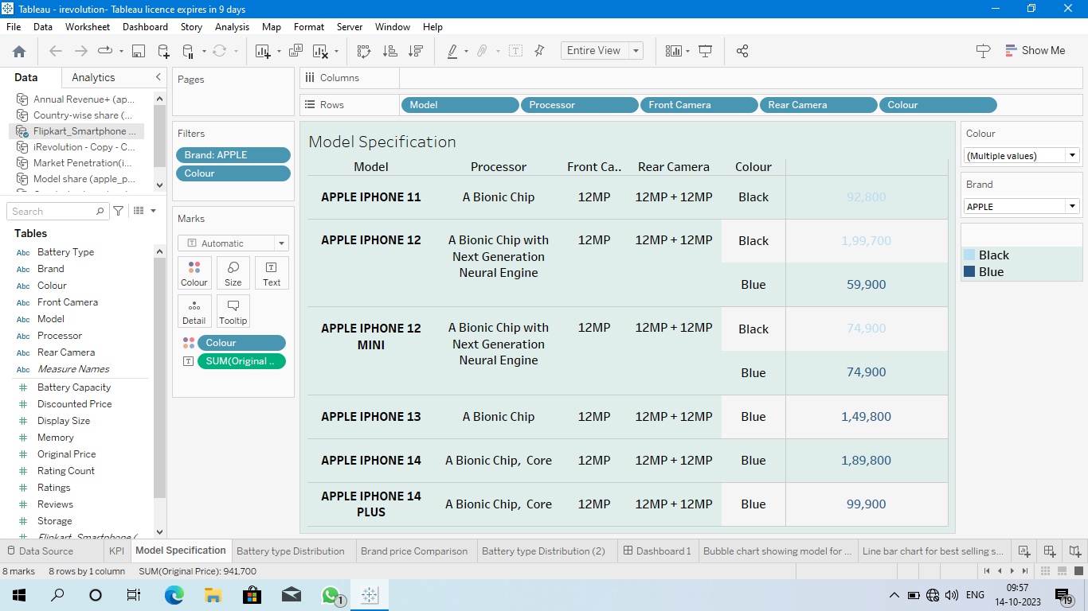

**Bar Chart showing Battery- Type**

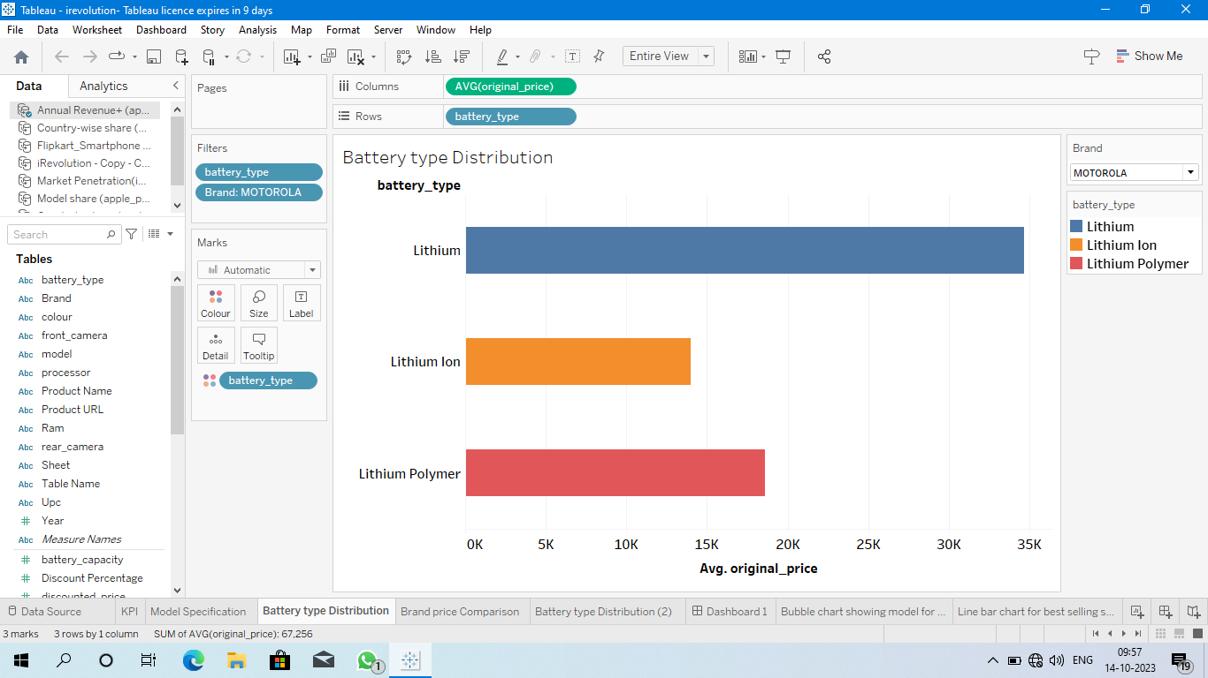

**Treemap showing Brand price comparison**

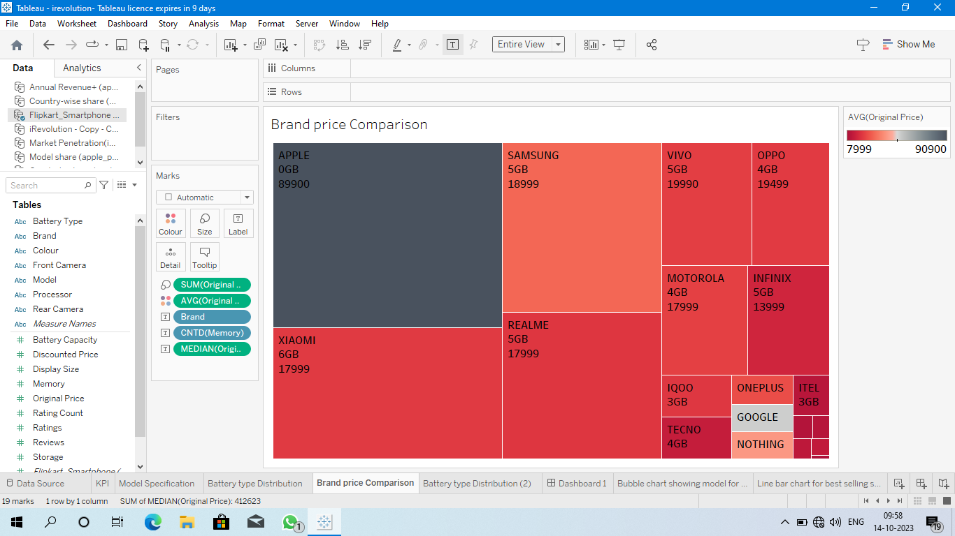

**Bubble chart showing model- wise share of iphone**

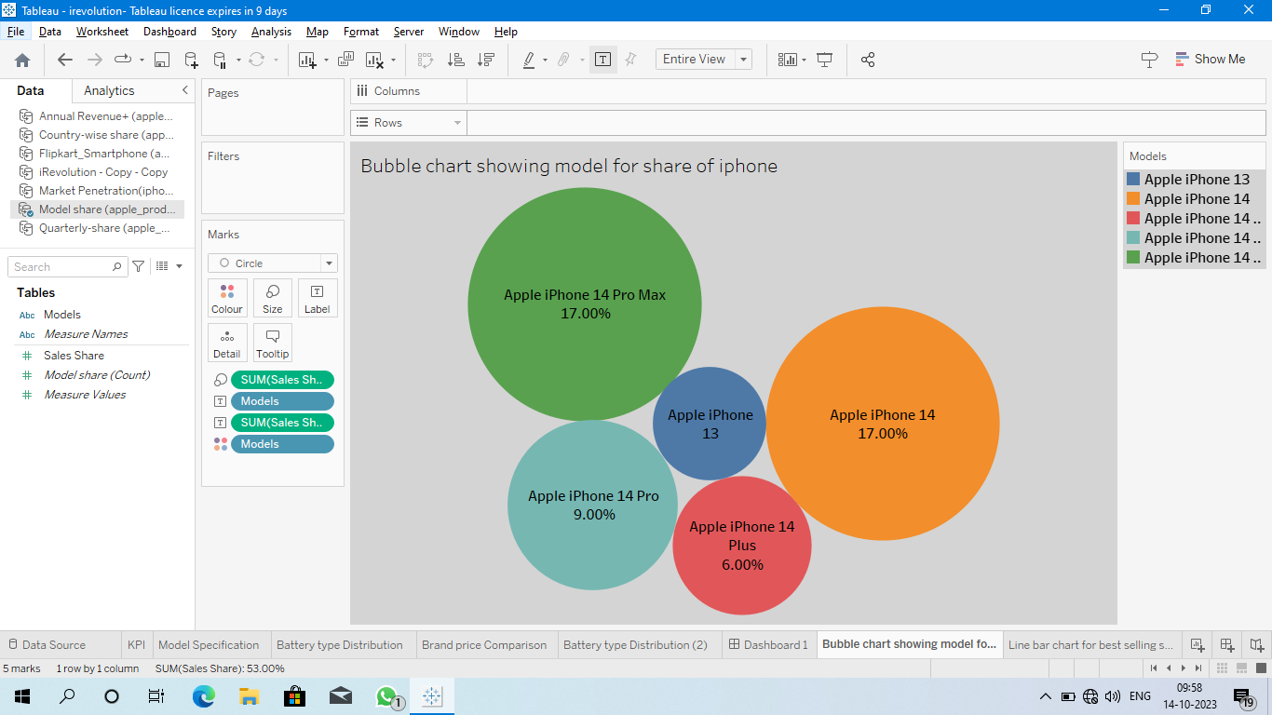

**Lined Bar-chart showing country wise selling smartphone**

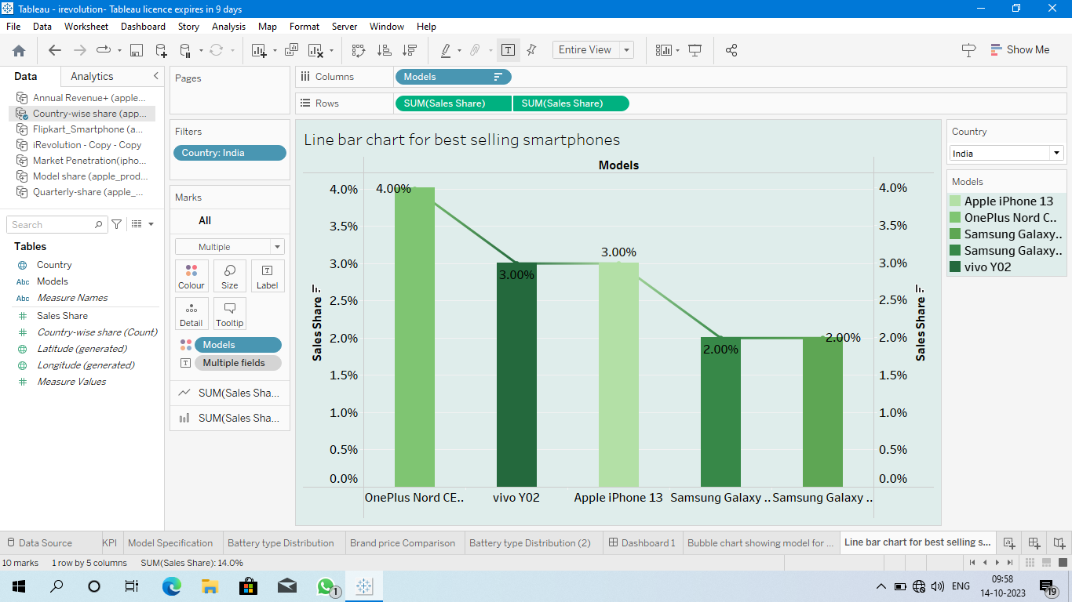

**Donut chart for Quarterly share**

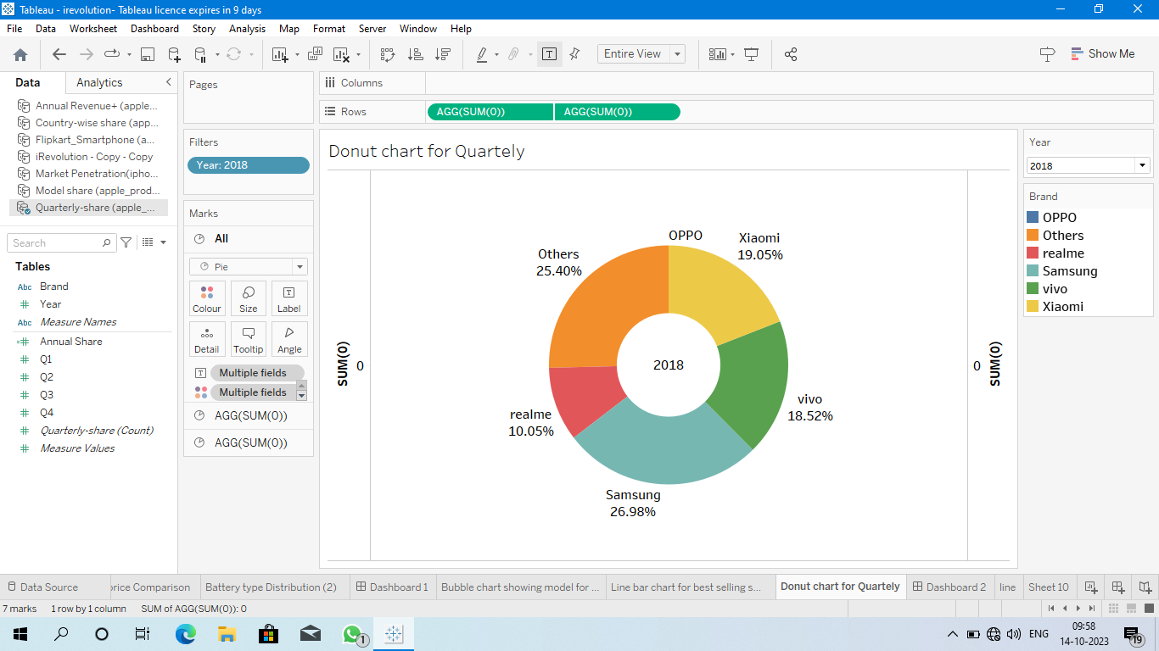

**Line chart for annual revenue Year wise**

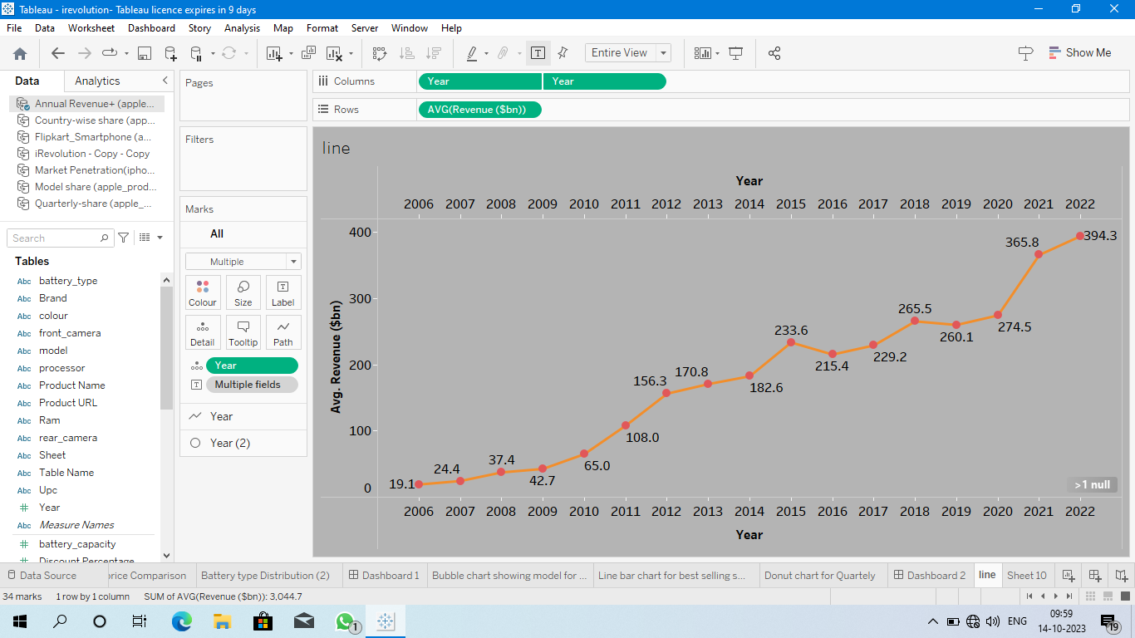

**Text table for yearly**

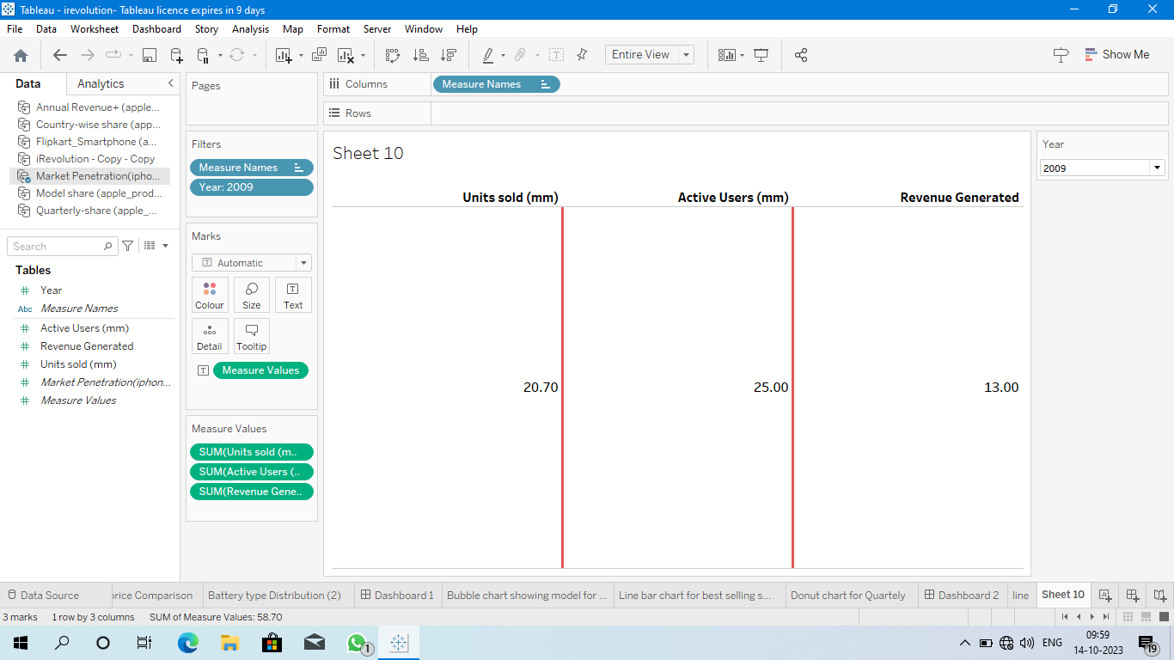

**Dashboard 1 :**

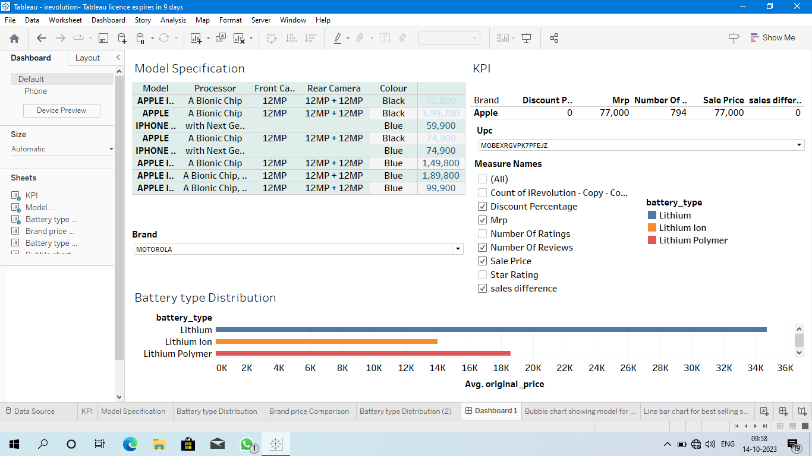

**Dashboard 2 :**

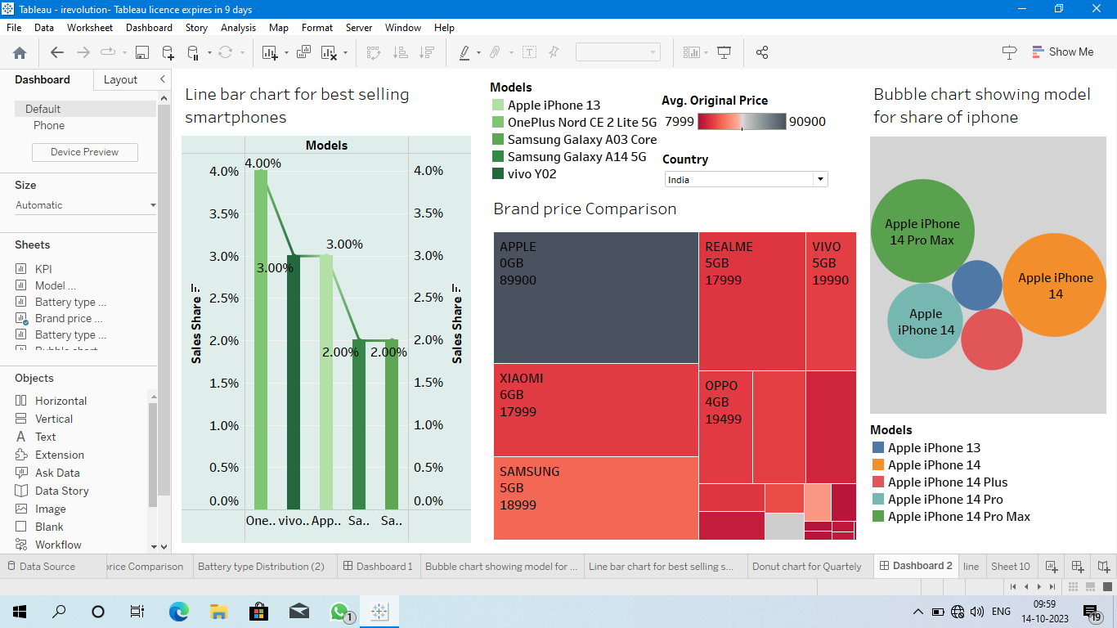

**Dashboard 3 :**

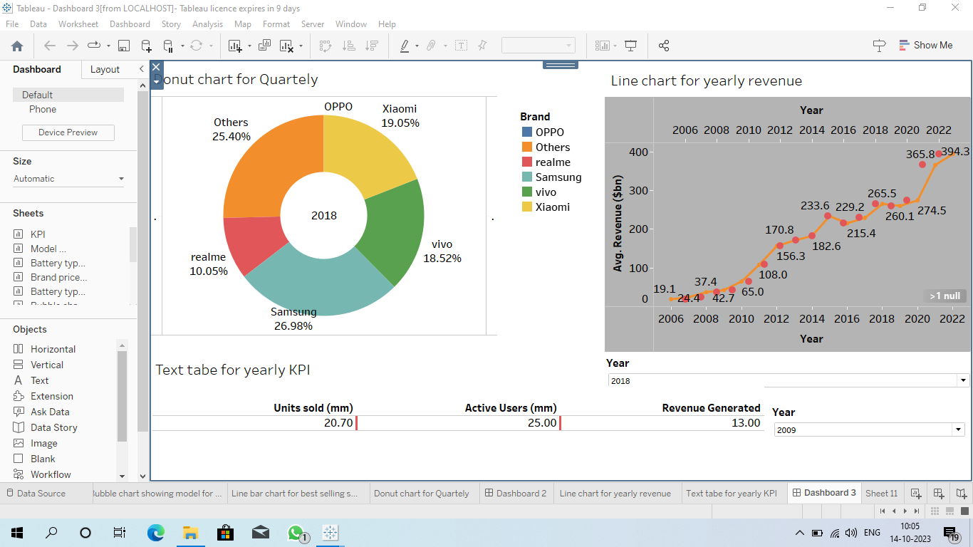

**Story 1 :**

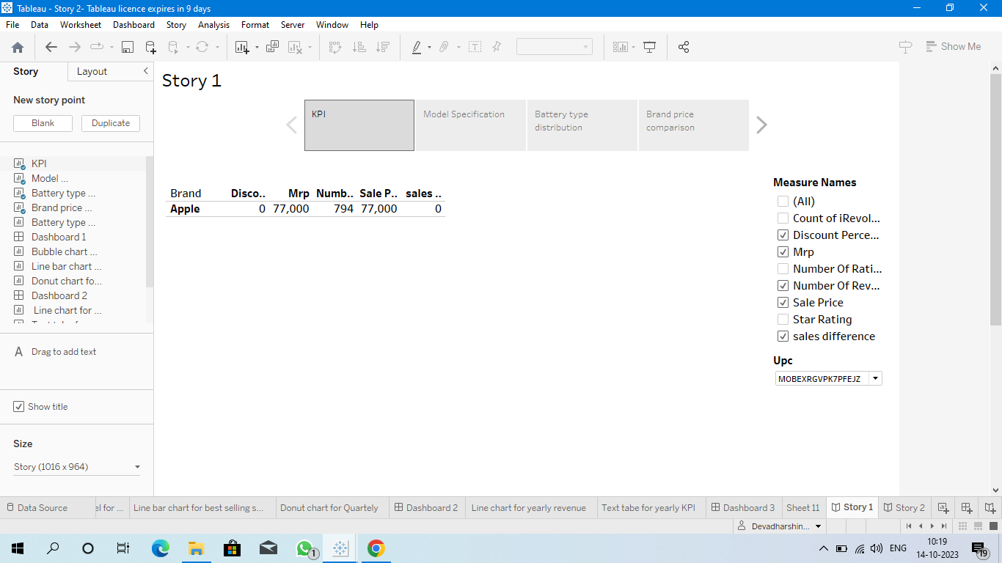

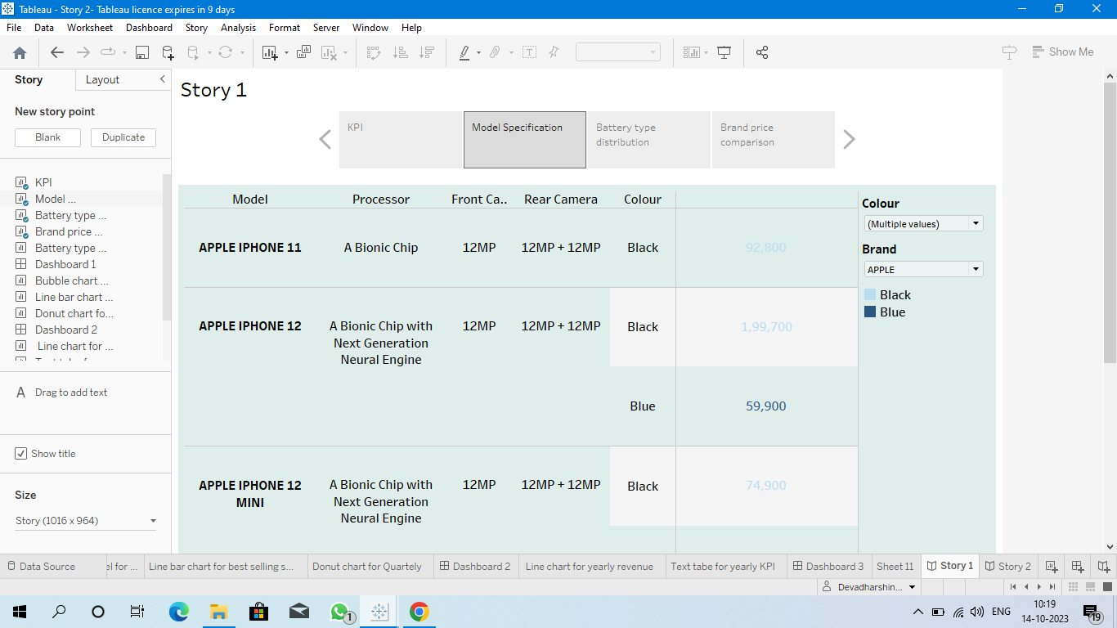

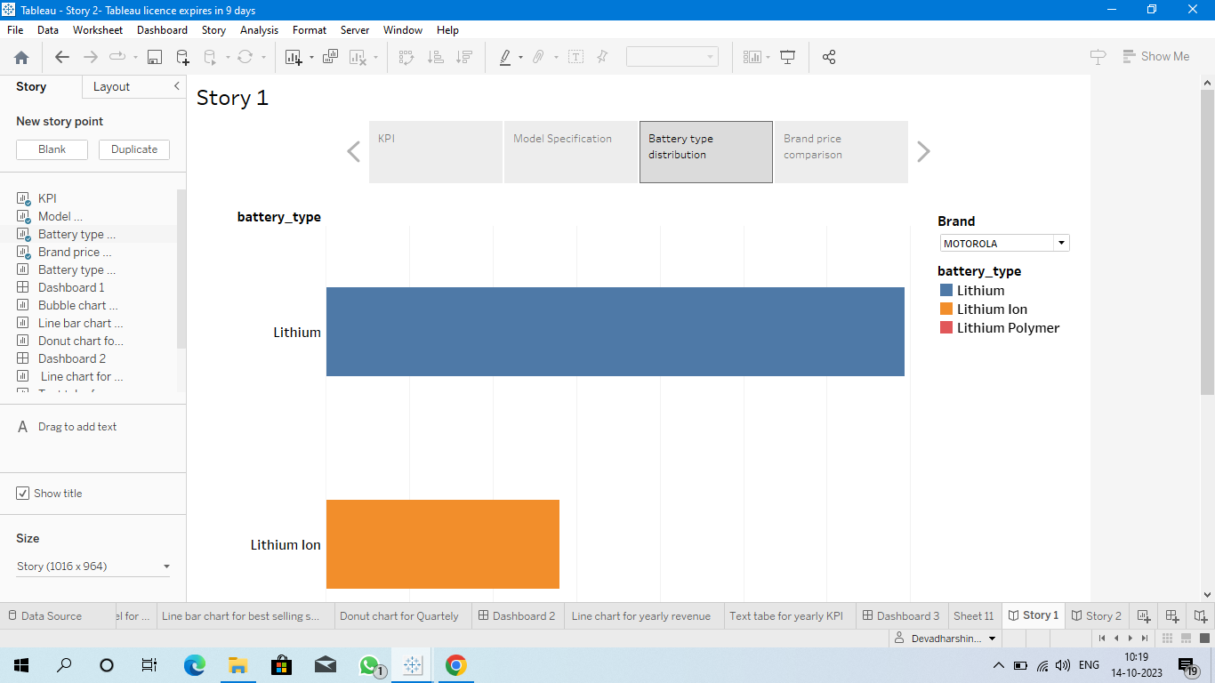

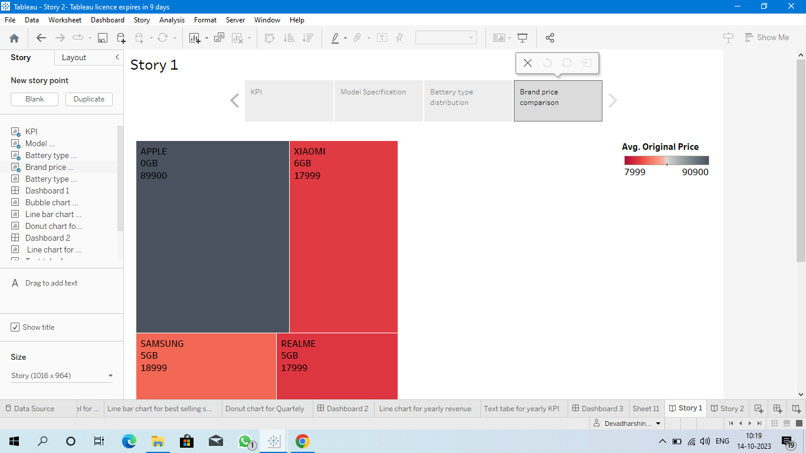

**Story 2 :**

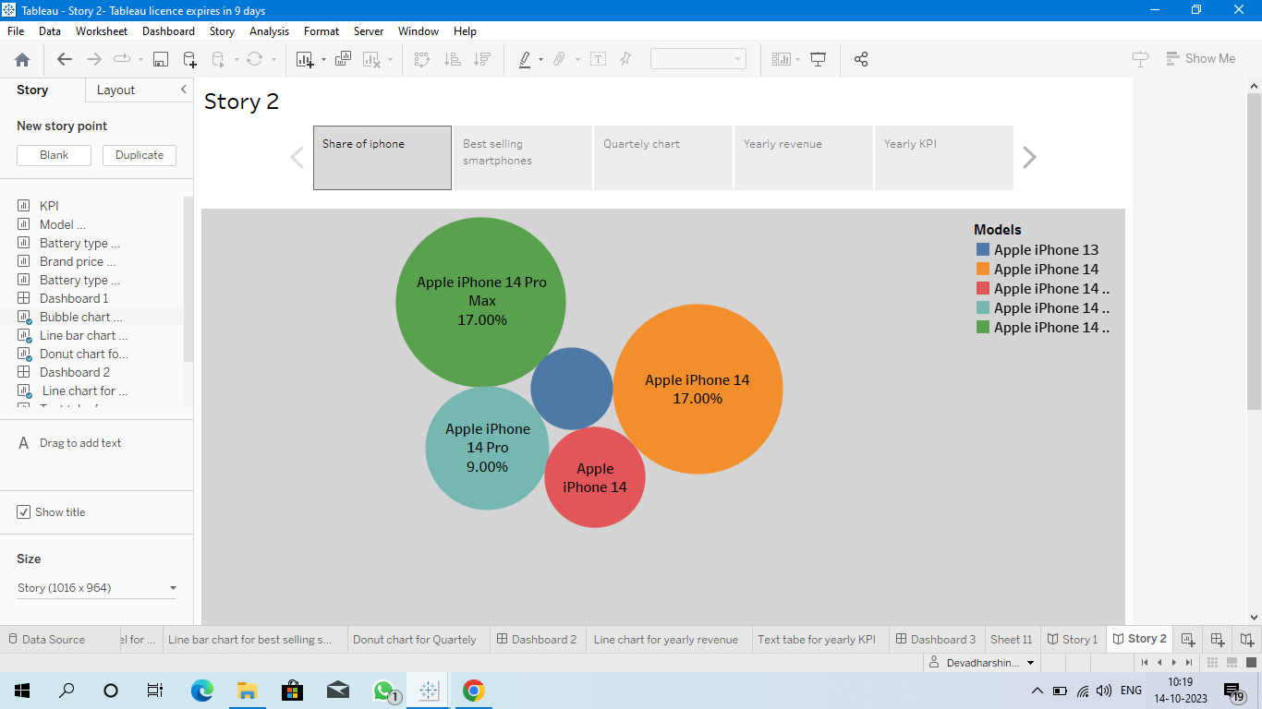

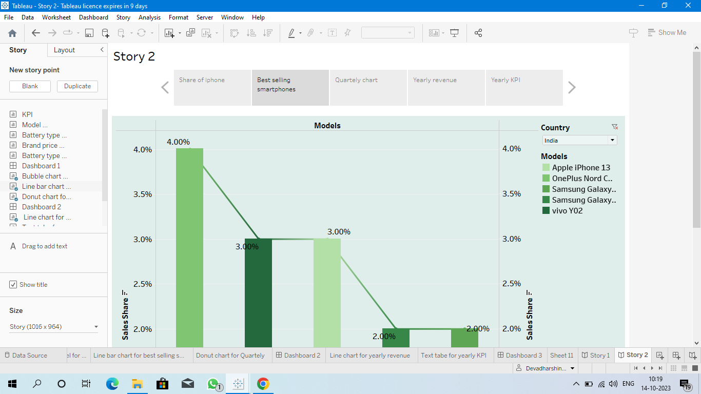

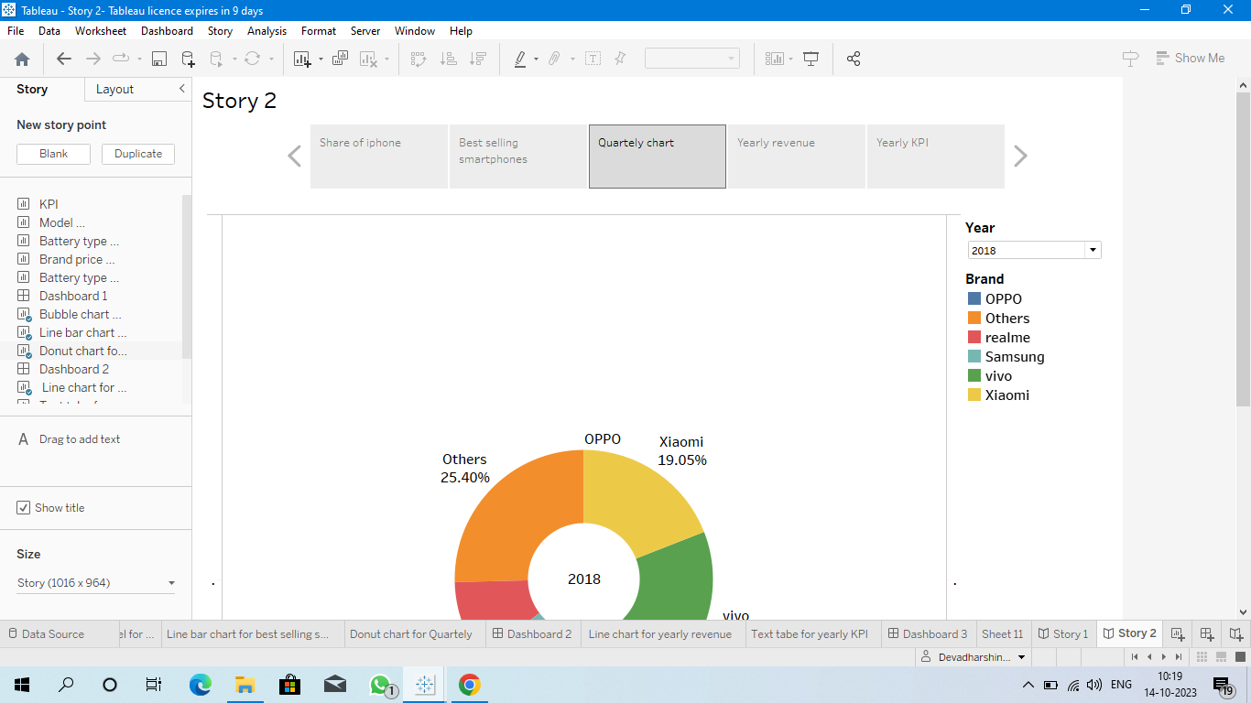

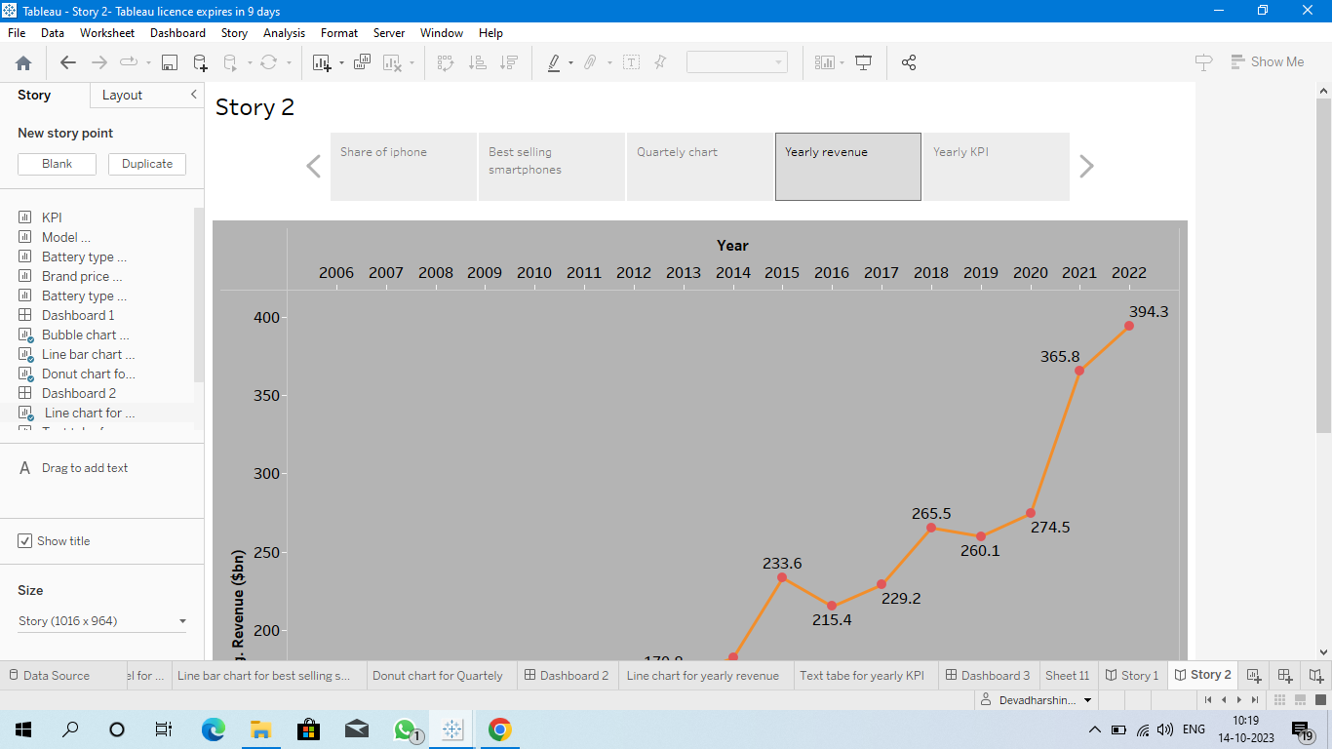

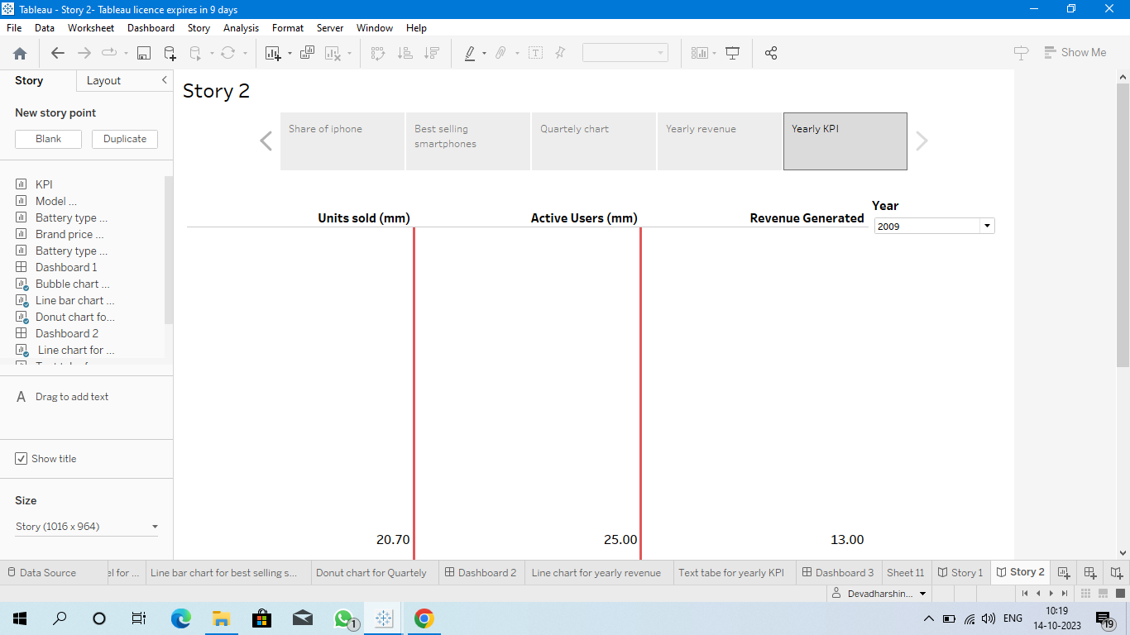

***4. Advantages :***

* **User-Friendly Interface: The iPhone has an intuitive user interface that makes it easy to navigate. The touch screen interface is easy to use, and the iPhone’s smooth operating system is simple to learn and use.**
* **High-Quality Display: The iPhone’s Retina display is one of the best in the market. With a density of over 300ppi, pictures and videos appear clear and crisp. This high-quality display is perfect for streaming TV shows, movies, and graphic-intensive games.**
* **Apps Ecosystem: The App Store is unparalleled in terms of access and ease of use. With millions of apps to choose from, users have access to a plethora of tools, games, and services that cater to their needs.**
* **Seamless Integration with other Apple devices: The iPhone has a seamless integration with other Apple devices such as MacBook, iPad, and Apple Watch. It allows users to access and transfer data across multiple devices.**

***Disadvantages***

* **Cost: The iPhone is one of the most expensive smartphones on the market. High-end models can cost over $1000, which makes it a luxury item for many people.**
* **Non-Removable Battery: The iPhone’s batteries are non-removable, which means that users cannot replace them. This can be a disadvantage for people who rely heavily on their phones and have to replace them regularly.**
* **Limited Customization: One of the disadvantages of the iPhone is that it has limited customization options. Unlike Android devices, users cannot customize their phone’s interface, which can be a disadvantage for some people.**
* **No Expandable Storage: Another disadvantage of the iPhone is that it has no expandable storage options. Users have to purchase iPhones with larger storage capacities, which can be costly.**
* **Frailty: The iPhone is known to be fragile and prone to breaking if dropped. Many users have reported cracking or shattering their screens after accidentally dropping their devices.**

**Conclusion**

**In conclusion, the iPhone has been a game-changer in the technological world. It has revolutionized the way people communicate and access information. However, its advantages and disadvantages must be weighed carefully by potential buyers. Ultimately, the choice of whether to purchase an iPhone depends on the user’s preference, needs, and budget.**

**FutureScope**

**iPhone application development has become one of the highest-paying businesses, especially in the last couple of years, with businesses worldwide jumping onto the platform. Its popularity isn't diminished because of Apple's constant commitment to offering the best to its users. The guidelines or rules set forth by Apple are extremely strict compared to industry standards. They should be followed by any business or developer planning to release an application on the platform.**

**IOS is the operating system of Apple has always enjoyed an honorable place in the digital realm and offers a highly specialized and unique approach to developing mobile apps for the platform. It is distinctive because it is a complex process that requires extensive planning and the right implementation when it comes to developing apps.**